**Strava**

Screenshots

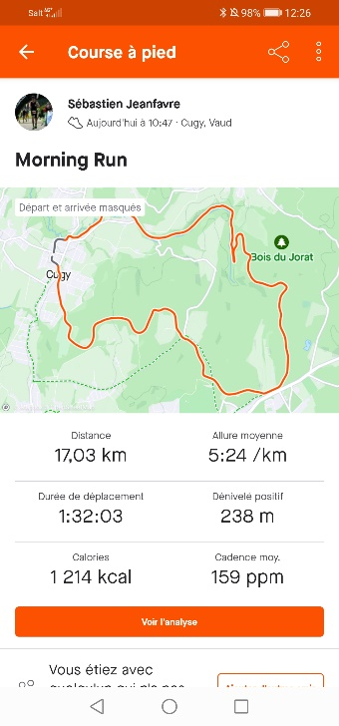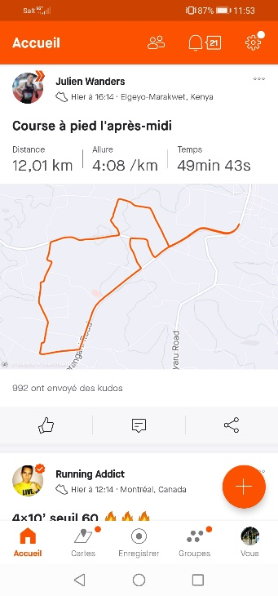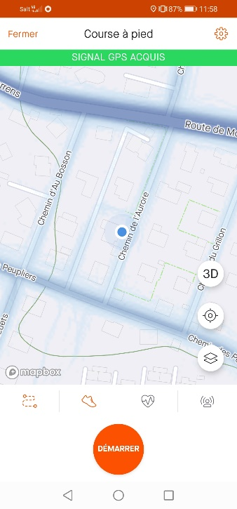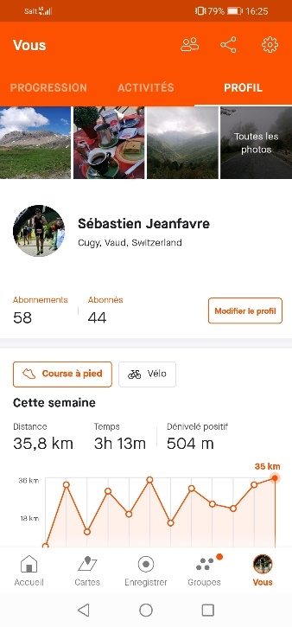

User’s profile Record an activity Activity analysis News feed

Value proposition

Strava is a social platform where one can record, track, and share sports activities with other casual or professional athletes in different sports as running, biking, or swimming. In this study, I will focus on the segment containing the runners only.

On the screenshots above, one can see four main functions available on the platform:

* **User’s profile:** This is the place where the user finds his/her activity records and a lot of statistics such as distances and elevation changes as well as the time spent training. The personal records over different distances are shown as well.
* **Activity record:** For those who do not own a connected watch and run with their smartphone, this function allows the user to record the route, pace and heart rate while running.
* **Activity analysis:** After having recorded an activity, one can see here the route, pace, time, heart rate, elevation gain and other statistics depending also on external monitors (HRM, power meter, etc…).
* **News feed:** Become a standard on most social platforms, Strava also offers a news feed where the user can see other users’ activities and comment on them. It can be friends but also professional athletes sharing their daily training. This is the place where most social interaction occur.

The following section presents a value proposition for the specific segment of runners.

Gains

* Share activities
* Track progression
* Store training data
* Find new routes in unknown places
* Compete with other athletes

Pains

* Lose progress and training data
* Get lost while running abroad
* Run too fast and struggle finishing the run
* Have difficulties calculating the distance run

Gain creators

* News feed allows to share activities
* Statistics on user’s training and fitness
* Record a run directly on the app to get the distance run
* Explore new places with the heat map
* Thanks to Strava segments, give your best on a given route and measure yourself against other runners

Pain relievers

* Safe online storage of training data and performances
* Route creator to make sure you don’t get lost in unknown places
* The displayed real time running pace helps managing your effort while recording a run

Usability evalutation

The usability evaluation is performed using the 10 following heuristics:

1. **Visibility of system status:** The user gets notified when something new happens, for instance a new posted activity, kudos (similar to likes, see below), new follower, etc.. A little dot appears on the bell icon and clicking on it displays all latest notifications.
2. **Match between system and the real world:** Available in 14 languages, all names are chosen to be consistent with reality which makes it natural for the user and very instinctive.
3. **User control and freedom:** When choosing a function from the main screen, an arrow pointing to the left appears so that the user can easily exit any unwanted state.
4. **Consistency and standards:** The equivalent of a "like" is called a “kudos” on Strava. It is not consistent with standards but has a deeper signification: it means from Greek “the glory and renown that come from a successful action”. Otherwise, the standards are followed.
5. **Error prevention:** Pretty good error prevention. For example, when stopping an activity record, the system doesn’t save the activity directly, is it possible to go back to the recording in the case the button “finish” was pressed by mistake.
6. **Recognition rather than recall:** This could be improved. Once a setting was modified, for instance who can see the user’s profile, the only way to retrieve it is to return to the settings whereas it could be indicated directly on the profile page.
7. **Flexibility and efficiency of use:** The platform has not much potential of “efficiency improvement and is not very flexible. However, its simplicity and ease of use makes it naturally efficient.
8. **Aesthetic and minimalist design:** The whole app is parsimonious and doesn’t clutter the screen unnecessarily with a minimalist design.
9. **Help users recognize, diagnose, and recover from errors:** The error messages are in plain text and clearly explained (example: “Activity Syncing Issues and Incorrect Start Times Due to GPS Rollovers”).
10. **Help and documentation:** FAQ and support are easily accessible in the settings. The support articles are very complete.

Finally, Strava is a platform that that encourages the practice of sports through a sense of community for users. Its minimalist design makes it easy to handle. It offers simple but crucial functions to the practice of running. Overall, it is a sound application in its principle, its development, and its use.